Poseidon 2250: SNMP monitoring & data logger
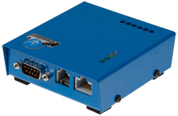
Poseidon 2250 logs the values from up to 40 probes (RS-485, dry contacts, temperature, voltage, etc.). Data are stored in a flash memory. The device enables monitoring over IP (Web, SNMP, Modbus/TCP) and sends alerts to values out of range (E-mail, SNMP trap, SMS over GSM). Industrial probes (4–20mA and Pt100/Pt1000) are supported. The supplied HWg-PDMS application enables native export of data to MS Excel.

Poseidon 2250 monitors the values of external probes and digital inputs. Values are stored in its flash memory (IP data logger function). Poseidon 2250 supports up to 40 probes, maximum distance is 1000 m.

Poseidon 2250 supports low-cost probes for short distance (IT environment), as well as precise industrial probes (Pt100 and Pt1000) or external probes (4–20mA current / 0–10V voltage) connected over RS-485.

Monitored values are available over HTTP, SNMP or Modbus/TCP protocols to external systems (SCADA, NMS). Stored values can be periodically e-mailed, imported into a database, or processed with MS Excel (Excel export via HWg-PDMS).
An external GSM modem can be connected to send SMS alerts.

With Poseidon 2250, you can monitor temperature, humidity, air-pressure, light, voltage, current, power, distance, CO₂, air-flow and many more sensors. Poseidon 2250 supports all sensors manufactured by HW group.

Typical applications include measuring and logging temperatures in a pharmacy. The Poseidon 2250 measures the temperature in four refrigerators, and monitors their doors. Values are stored in the flash memory and periodically e-mailed to a central server for processing, optionally with e-mail alerts.

- Online demo: http://poseidon.hwg.cz
- Ethernet: RJ45 (10BASE-T)
- Logging of values: data logger with internal flash memory, 384 KB
- Web: Built-in web server
- Sensors: 1xRJ11 1-Wire UNI (max. 10 temperature/humidity probes)
- RS-485 sensors: 1xRJ45 (max. 26 probes – temperature, humidity, air pressure, voltage, current, Pt100, Pt1000, …)
- Digital Inputs: 3 digital (dry contact) inputs
(door contact, smoke detector, 110/230VAC supply detector, water leak detector, cooling fan failure detector)
- GSM modem: A GSM modem for sending SMS alerts can be connected to RS-232
- Mechanical: Wall mount, dimensions: 25 x 82 x 90 [mm]
- Alerts (value out of defined safe range): SNMP trap, Email, SMS
- M2M communication protocols: SNMP, XML, Modbus/TCP
- Support for programmers: HWg SDK
- Supported software
  - HWg-PD Trigger: Alert redirection to SMS, pop-up messages, PC shutdown...
  - HWg-PDMS: Logging of values, graphs, export to MS Excel
  - CapTemp: Visualization on a map, control of outputs, alarm redirection to SMS
  - Third-party SNMP software

Keywords:
Poseidon 2250 snmp monitoring and logger, SNMP voltage & current logger, temperature sensor IP data logger, pt100 temperature sensor over rs-485, 4-20mA and pt-1000 probes

modbus/tcp voltage input, snmp light sensor, rs485 temperature and humidity sensors, SNMP monitoring, snmp trap alert, email alert, web sms alert, remote sensors monitoring, web sensors, excel export

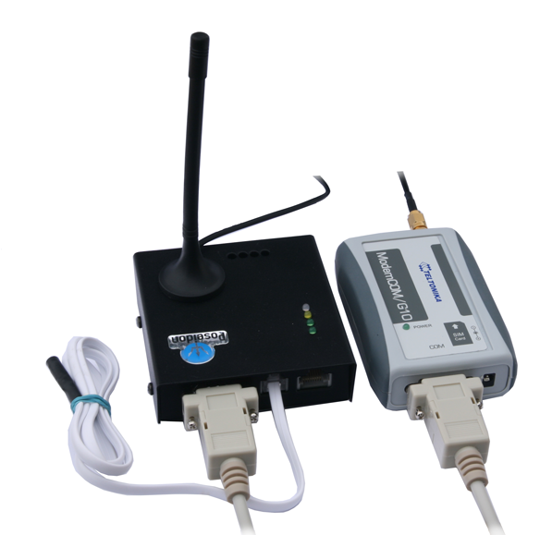
Poseidon 2250 GSM Tset: GSM Temperature & IP logger package
A complete package for autonomous environment monitoring (temperature / humidity) in industrial applications. Autonomous recording of temperatures and alerting over SMS only depends on the supply of power.

The package contains a temperature probe, a GSM modem and a Poseidon 2250 unit. Logged temperature can be periodically e-mailed.
When the temperature is too high or too low, SMS alert is sent to two different phone numbers. If the LAN connection works OK, e-mail and SNMP trap are sent as well.

Native data export to MS Excel using the HWg-PDMS software.

It is possible to add over 40 additional sensors of various types (voltage, current, humidity, contacts, etc.).

Package contents: “Poseidon 2250 GSM Tset” contains a Poseidon 2250 unit, one temperature probe, a GSM modem with an external antenna, connecting cables, and a CD with software – everything you need to get started (except a SIM card).

- Online demo: http://poseidon.hwg.cz
- Ethernet: RJ45 (10BASE-T)
- Web: Built-in web server
- Sensors: 1 temperature probe is included (max. 44 probes can be connected in total)
- GSM modem: The package contains a GSM modem for sending SMS alerts
- Alerts (value out of defined safe range): SNMP trap, E-mail, SMS via GSM modem
- M2M protocols: SNMP, XML (http), Modbus/TCP
- Support for programmers: HWg SDK
- Supported software
  - HWg-PD Trigger: Alert redirection to SMS, pop-up messages, PC shutdown...
  - HWg-PDMS: Logging of values, graphs, export to MS Excel
  - CapTemp: Visualization on a map, control of outputs, alarm redirection to SMS
  - Third-party SNMP software

