Poseidon2 4002: Data center environment monitoring
Poseidon2 4002 is a system for remote monitoring of rack environmental conditions (occupies 1U). It monitors temperature, power supply, door contacts, and more. Poseidon is SNMP compatible, includes a data logger, e-mail and SMS alerts. It can be connected to the SensDesk online portal or cloud sensor systems.

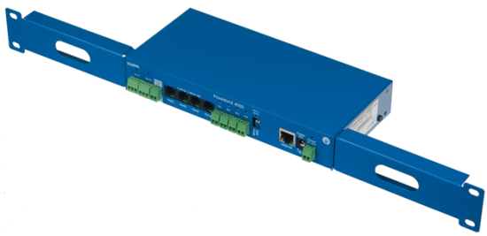
Poseidon2 4002 is a remote datacenter environmental monitoring solution.
It alerts to opened door, high temperature and humidity, or other sensor readings. Typical applications include remote rack or server room alarm monitoring.

Monitor your computer room temperature via SNMP (Nagios, Cacti, OpenView, ..) or with a smartphone app.

Poseidon2 4002 is a 1U 19” rack mount device for one network cabinet environmental monitoring or entire server room monitoring. Up to 16 external sensors and 12 detectors (digital inputs) can be connected.
Four relay outputs can be controlled over the Web, or according to the value of a connected sensor, for example to control air conditioning or ventilation.

Poseidon can be used as a standalone environment monitoring device with email alerts or as a part of a complex monitoring system (SNMP or SensDesk online portal).

The device can be accessed over the web, using a mobile phone app (Android/iPhone), or through an online portal. Alerts can be sent by e-mail or SMS (text message), for example whenever the cabinet door opens. Poseidon2 4002 can be connected to an external GSM modem.

For data collection and monitoring, we recommend our HWg-PDMS application that displays graphs and exports data to MS Excel.
For “IF-THEN” event management (e.g. “If one out of 10 devices fails, send a SMS to the admin”), we provide the HWg-Trigger application for Windows.

For remote monitoring of several sites, the SensDesk.com online service can be used. It can display readings from sensors at multiple Poseidon2 units and other HW group products on a single screen. The online portal is configured over the web and all devices can monitored with a mobile phone app.

Poseidon2 can be connected to various monitoring systems. We support over 50 different third-party SNMP or SCADA applications.

- Online demo: http://poseidon2.hwg.cz
- Ethernet: RJ45 (100BASE-T)
- WEB: Built-in web server
- Sensors: 6xRJ11 – max. 16 external sensors (1-Wire / 1-Wire UNI)
- Can measure: Indoor and outdoor temperature, humidity, light in the room, voltage, current (0-30A or 4-20mA), external temperature probes (Pt-100, Pt-1000), and more...
- Digital outputs: 4x DO (relay output)
(remote restart, fan control, server power control, network I/O)
- Digital inputs: 12x DI for dry contacts (status detectors)
(smoke detector, door contact, water flood detector, fan failure detector)
- RS-485 support: Yes, supports supplied external sensors
- Data logger: over 250,000 records
- Power: 9-30V DC
- Operating temperature: –30°C to +85°C (–22°F to +185°F)
- Mechanical: metal case, occupies 1U in a 19“ rack
Dimensions: 100 x 213 x 35 [mm]
- Warranty: 5 years

- Alerts (value out of defined safe range): SNMP trap, E-mail, SMS
- Cloud support: HWg-Push protocol
- GSM modem: A GSM modem for sending text messages (SMS) can be connected to RS-232
- Text messages (SMS): Alerts can be sent as text messages (SMS) via a local GSM modem or a remote „HWg-SMS-GW“ over the network. Up to 5 recipients, no software is needed.
- M2M communication protocols: SNMP, XML, Modbus/TCP, HWg-Push
- Support for programmers: HWg-SDK
- Online portal: SensDesk.com (remote monitoring of several devices / sensors over the web free of charge).
- Supported software
  - HWg-Trigger: Alert redirection to SMS, pop-up messages, PC shutdown...
  - HWg-PDMS: Logging of values, graphs, export to MS Excel
  - Third-party SNMP software

Keywords EN v2:
Poseidon2 4002, data center environmental monitoring, server room alarm monitoring, rack environmental conditions, temperature and humidity, computer room temperature, room alert, environment monitoring system

email alert, smoke detector, temperature logger, current sensor, voltage sensor, temperature sensor, water leak detector, temperature measurement, door contact, server monitoring, environmental monitoring, snmp, network cabinet, remote monitoring, cabinet doors monitoring, 1u server room monitoring,

