PowerEgg2: 110/230V power detection and switching
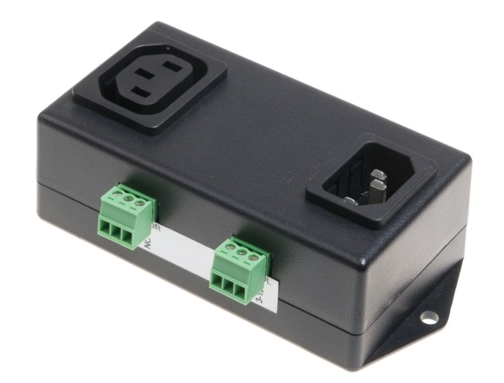
PowerEgg2 combines two functions in one device -power Detector & Control. Detector indicate failures of electricity supply (110/230V, single phase) by relay output. Power Control can switch Off/On power supply output 8A, it's controlled with a low voltage input. The PowerEgg can be connected to any device with digital inputs (DI) and digital outputs (DO).

The PowerEgg2 combines two functions in one device:
- Detector: Detects voltage, its presence is indicated with a relay output (electrically isolated).
- Control: Controls an output electricity socket, max. 8A.
PowerEgg2, together with e.g. Poseidon 3266 or Damocles MINI, can be used to monitor the presence of the line voltage at the input of an UPS.
PowerEgg2 can disconnect its output with a relay contact; this can be used, for example, to remotely switch off and switch on a server.
Both functions are electrically isolated, and can be connected to any dry contact input or a relay output.

- DETECTOR Input: Voltage detection (110/230V) - IEC-320 C14
- DETECTOR interface: Connect to any dry contact DI (digital input)
- CONTROL Output: Turns on/off the 110/230V output voltage (max 8A) – can be connected to any digital output - IEC-320 C13
- CONTROL interface: Connect to any DO (digital output) - relay or open collector
- Compatible with: Poseidon 3266, 3268, 3468, 4002, 2250
Damocles 1208, MINI, 2404, I/O controller XXXX, HWg-Ares

Keywords:
PowerEgg2, power detector, 110V/230V AC detection, IEC-320 C13 voltage detection, IEC-320 C14 power output, detection and switching, relay power control

