HWg-Ares 12: GSM/GPRS thermometer with SMS & Email
Sensors & DI monitoring over GSM/GPRS. Comfortable standalone solution or part of mixed LAN & GPRS system for hundreds of sensors.
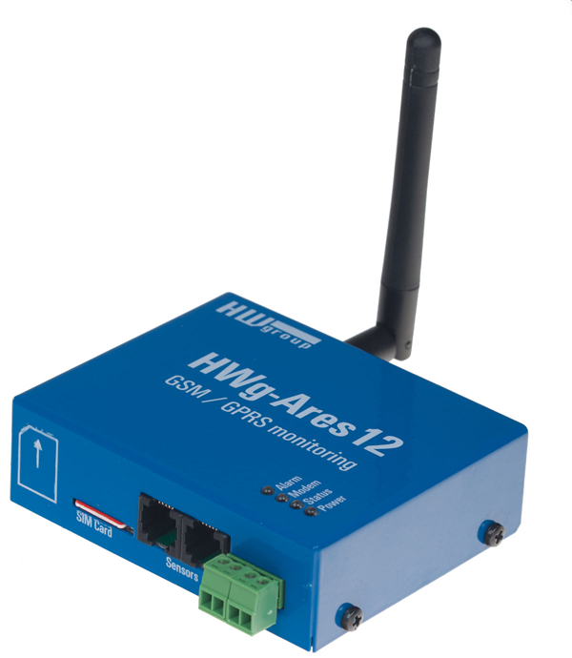
HWg-Ares 12 is a remote environment monitoring solution that can be installed in a few minutes. It only needs GSM signal coverage. The device contains an internal back-up battery. If the external power fails, up to 5 recipients are alerted by e-mail or text message. The HWg-Ares 12 can be used even as a simple GSM thermometer.

Simply connect external sensors (temperature, 4-20mA, humidity, light and other sensors) or two dry contacts and monitor all probes remotely. Sensor data can be read into HWg-PDMS (free software), connected with a Web portal or passed to a SCADA/NMS system.

The Ares platform is ready for remote installations with hundreds of units. Despite that you can easily start with just one HWg-Ares 12 unit and see graphs in the supplied HWg-PDMS software or in XML exported data.
HWg-Ares is a complete GSM monitoring system – from sensors to MS Excel data export. GPRS traffic is cost-optimized. The unique feature is that you can mix LAN based IP sensors with the GSM/GPRS HWg-Ares devices. There is an available plugin for Nagios – most popular free SNMP monitoring software.

- Internal battery: Remote monitoring backup for several hours
- Sensors: Up to 3 1-Wire UNI sensors can be connected (Temperature, Humidity, Light, 4-20mA, 0-60V, Pt100/1000 with ext. converter)
- DI inputs: 2 dry contact inputs for external detectors/sensors
- Counters: Pulse counter on each DI for S0 pulses
- Alarm alerts: Dialing a number, SMS (5 destinations), Email, HWg-Push
- Logger: Data available as email attachments or on the USB mass storage.
- Remote configuration: Web interface, tab „AresConf“ in the SensDesk.com portal.
- Software: SensDesk.com portal, Nagios plugin, 3rd party solutions
- Mobile application for data overview: Android and iPhone (via SensDesk.com)
- USB interface: configuration software for Windows, no installation needed
- Remote firmware upgrade (FOTA) capability simplifies management of large-scale installations with hundreds of devices.
- One temperature sensor included in the “Tset” package. Up to 60m cable.
Keywords:
HWg-Ares 12, GSM thermometer, sms temperature alert, IP sensor over GSM, Nagios GSM sensor, alarm thermometer

GSM temperature sensor, humidity measurement over gsm, sms dry contact, GPRS remote monitoring, wireless temperature sensor, GSM remote monitor, GSM supervision, nagios plugin, gsm monitoring system, temperature logging, battery backup GSM monitor, GPRS temperature monitoring, , sms monitoring, temperature sms

