Poseidon2 3468: IP Thermostat with 230V/16A relay outputs
Web thermostat with 4 digital inputs, external sensors (voltage, temperature, illumination, humidity, ...) and 2 relay outputs rated at 110/230V. Industrial solution (fits on a DIN rail). Supports e-mail, SNMP, Modbus/TCP, and the Sensdesk.com online portal.
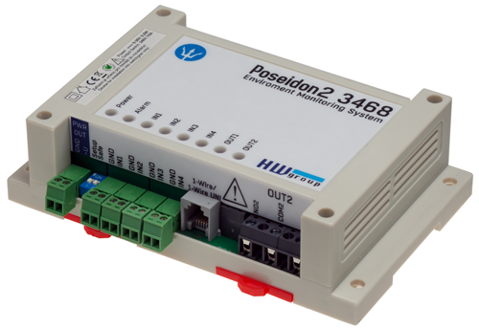
Poseidon2 3468 is designed for industrial alerting applications. Based on external sensor readings, Poseidon 3468 sends alerts or activates relay outputs.
Output relays can directly switch 110/230VAC. The product is CE compliant.

E-mail or SNMP Trap is sent whenever a value at a sensor exceeds its specified range.

A minimum closed contact time condition to send the alert can be specified. For instance, “Send an e-mail when the door is open for longer than 120 seconds.”

Relay outputs can be controlled remotely over the Web, or from a software application (XML, SNMP, Modbus/TCP).

A typical application is an “IP thermostat” or an “IP hygrostat”. The relays control heating or cooling (fan) using an external temperature, humidity or other sensor.

- Online demo: http://poseidon2.hwg.cz
- Ethernet: RJ45 (100BASE-T)
- Web: Built-in Web server
- Sensors: 2xRJ11 for 8 external sensors (1-Wire / 1-Wire UNI)
- Digital Inputs: 4 digital inputs (dry contact)
(door contact, smoke detector, 110/230VAC power detector, water leak detector, cooling fan failure detector)
- Digital Outputs: 2 digital (relay) outputs (230VAC/16A)
(air conditioning, server power, horn/light tower)
- You can measure: Humidity, Voltage, Current, 4-20mA, Light, Temperature (even Pt100, Pt1000) and many more..
- Logging of values: more than 250.000 records (internal flash memory)
- Power: 9 to 30V DC, but also -48V DC (Telco standard)
- Mechanical: Fits on a DIN rail, 145 x 90 x 45 [mm]

- Local built-in functions: Output control according to sensor value or digital input (“thermostat” mode)
- Alerts (value out of defined safe range): SNMP trap, Email, HWg-Push
- Text messages (SMS): Alerts can be send as text messages (SMS) over a remote “HWg-SMS-GW“ on the network. No software needed.
- M2M communication protocols: SNMP, XML, Modbus/TCP, HWg-Push
- Support for programmers: HWg-SDK
- Recommended online portal: SensDesk.com – Free online portal
- Supported software
  - HWg-Trigger: Alert redirection to SMS, pop-up messages, PC shutdown...
  - HWg-PDMS: Logging of values, graphs, export to MS Excel
  - Third-party SNMP software

EN Keywords:
Poseidon2 3468, IP thermostat, web enabled thermostat, IP relay 110V, web relay 230V, remote thermostat, internet thermostat, temperature logger, hygrometer, powered by -48V DC,

modbus relay, snmp relay, humidity controller, Ethernet relays, snmp thermostat, humidity control, remote control thermostat, thermohygrometer, IP-relay, Modbus/tcp sensor, DIN ethernet relay,pt100, 4-20mA, pt1000

